Atomic Designe:

* Atoms: They are the minimum components
* Molecules: Grouping of 1 or more atoms.
* Organisms: Grouping between molecules and between molecules and atoms.
* Templates: Grouping of all the above (each screen)

# Templates:

/dashboard

/transaction

/all-transactions

/update-transaction (to be defined)

## Atoms:

### Button:

Properties:

* className
* Icon
* Text

Variants:



### BarChar:

* Total expenses per category
* Total budget per category
* BarChar: https://codesandbox.io/s/sharp-mestorf-7i8bxj?file=/App.tsx

Variants:

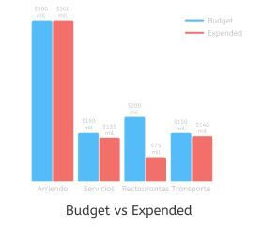

### Box:

Properties:

* Icon
* TransactionType
* TotalAmount

Variants:



### Title:

Properties:

* Text

### TextArea:

Properties:

* Label
* Icon
* Content

Variants:



## Molecules:

### NavBar:

Properties:

* Button Left
* Button Right

Variants:



### HalfDonut:

Properties:

* HalfDonutChar: <https://codesandbox.io/s/sparkling-night-tktih0>
* PercentageProgress
* TotalIncomes

Variants:

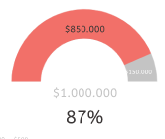

### Footer:

Properties:

* Button x 3

Variants:



### Input:

Properties:

* Icono
* Label
* Tipo (textbox/button)
* Placeholder
* Value

Variants:



### ListButton:

Properties:

* categoryList
* Buttons



### TransactionCard:

Properties:

* Icon
* Description
* Category
* Amount
* className

Variants:



### ConfirmationModal:

Variants:



## Organisms:

### Form:

Properties:

* TransactionType
* CategoryValue=Null/Saved
* DateValue=CurrentDate/Saved
* AmountValue=Null/Saved
* DescriptionValue=Null/Saved
* Input x 3
* TextArea
* Button x 2

Variants:



### CategoryModal:

Properties:

* CategoryList
* Title
* ListButton
* Button

Variants:

